|  |  |  |
| --- | --- | --- |
| TITLE | **:** | **TENDER FOR FURNITURE OF GIRL’S DORMITORY PHASE I** |
| OWNER | **:** | **THE LAWRENCE SCHOOL, SANAWAR** |
| ADDRESS | **:** | **The Lawrence School, Sanawar** |
|  |  |  |
| TYPE OF TENDER | **:** | **TENDER** |
|  |  |  |
|  |  |  |
|  |  |  |
| LAST DATE OF SUBMISSION OF TECHNICAL BID DOCUMENT | **:** | **15.07.2023** |
|  |  |  |
|  |  |  |

|  |  |  |
| --- | --- | --- |
| **TENDER SCHEDULE** | | |
| Validity Of Offer | : | 45 Days |
| Last Date of Submission of Tender. | : | 15.07.2023 |
| guarantee | : | 24 Months |
| Contract Time Period. | : | 45 Days |
| Penalty For Delay. | : | Rs. Upto 5,000/- Per Day. |
| Retention Percentage. | : | 5% |
| Contact Details for Clarification Related to Tender. | : | Email: [hdp@sanawar.edu.in](mailto:hdp@sanawar.edu.in) , purchase@sanawar.edu.in  Phone. 8982763396 ,9418733574 |

# ELIGIBILITY CRITERIA

|  |  |  |
| --- | --- | --- |
| **S. NO.** |  | **DESCRIPTION** |
| **1)** | **:** | **BIDDER SHOULD HAVE COMPLETED THREE SIMILAR WORKS EACH COSTING NOT LESS THAN RUPEES 30 LAKHS.** |
| **2)** | **:** | **BIDDER SHOULD HAVE AVERAGE ANNUAL TURNOVER (GROSS) OF 50 LAKHS** |

# CHECKLIST OF DOCUMENTS TO BE PLACED IN THE TECHNICAL BID

|  |  |  |  |
| --- | --- | --- | --- |
| **S.NO.** |  | **DESCRIPTION** | **CHECK** |
| 1) | : | COMPANY REGISTRATION DETAILS | ☐ |
| 2) | : | COMPANY PROFILE | ☐ |
| 3) | : | GST REGISTRATION CERTIFICATE COPY | ☐ |
| 4) | : | PAN CARD COPY | ☐ |
| 5) | : | VALID COMPLETION CERTIFICATES | ☐ |

# SUBMISSION OF TECHNICAL BID

1. **THE TECHNICAL BID DOCUMENTS HAVE TO BE SCANNED AND SEND TO THE EMAIL ID** [**purchase@sanawar.edu.in**](mailto:purchase@sanawar.edu.in) **(Password Protected)**
2. **HARDCOPY OF THE TECHNICAL BID DOCUMENTS SHOULD BE SUBMITTED TO MAIN GATE OF THE LAWRENCE SCHOOL, SANAWAR ON OR BEFORE 3:00 PM ON 15.07.2023.**

# NOTICE INVITING TENDER

To

All the Eligible Bidders,

Dear Sir/ Madam,

You are invited to submit your most competitive **ONLINE** Quotation through the Hard copy and by Gmail in (TECHNICAL & FINANCIAL) on or before the prescribed due date and time for TENDER FOR FURNITURE OF GIRL’S DORMITORY PHASE I, THE LAWRENCE SCHOOL ,SANAWAR,

Manual Bids shall not be accepted, except for the supportive documents / instruments if any asked in this tender. However, bidders are requested to submit hardcopy technical bid on or before the tender due date mentioned in the tender document.

The complete details of the tender items are available in the tender document,

# TENDER ACCEPTANCE (OFFER) LETTER

TO,

The Headmaster,

The Lawrence School, Sanawar

Subject: Acceptance in respect of terms and conditions of tender document for TENDER FOR FURNITURE OF GIRL’S DORMITORY PHASE I, THE LAWRENCE SCHOOL, SANAWAR.

Dear Sir,

1. I / We hereby certify that I / We have read every page of the tender document including all terms/conditions/drawings/annexures/forms/appendixes/paras etc. which are part of the contract agreement and I / we agree to accept all the terms and conditions contained therein.
2. I / We hereby unconditionally accept all the terms and conditions of above-mentioned tender document and corrigendum(s) as applicable.
3. 1 / we hereby certify that all statements made and information supplied in the enclosed appendix, annexure, forms/paras etc. furnished herewith are true and correct.
4. I/We understand and accept that all taxes including GST shall be payable by the bidder/contractor and The Headmaster, The Lawrence School, Sanawar will not entertain any claim whatsoever in respect of taxes.
5. I/We understand and accept that The Headmaster, The Lawrence School, Sanawar reserves the right of accepting the whole or any part of the tender and the bidder/contractor shall be bound to perform the same at quoted rates.

Yours Faithfully,

Signature of Bidder: Name:

Designation:

Stamp of the Bidder:

# BIDDER’S DETAILS

|  |  |  |
| --- | --- | --- |
| **S.NO.** | **DESCRIPTION** | **DETAIL** |
| 1 | Name of Company |  |
| 2 | Address of Company |  |
| 3 | PAN no. |  |
| 4 | GSTN no. |  |
| 5 | Telephone Number |  |
| 6 | Email Address |  |
| 7 | Name of Company Owner  / Director / Partner |  |
| 8 | Address of Company Owner / Director / Partner |  |
| 9 | Telephone Number of Company Owner / Director/ Partner |  |
| I/We hereby declare that the information furnished above is true and correct. In case the above information is found incorrect at any stage, The Headmaster, The Lawrence School, Sanawar may take appropriate action as warranted. | | |
| Name: | |  |
| Designation: | |  |
| Stamp & Signatures: | |  |
| Place: | |  |
| Date: | |  |

# SPECIAL CONDITIONS OF CONTRACT

1. No material advance will be given, However 75% may be released after material delivery at site & scrutiny of engineer in charge.
2. CONTRACTORS are advised to inspect and examine the site and the surroundings and satisfy themselves before submitting their Tender as to the nature of the site the form and the nature of the site, the means of access to the site, the accommodation they may require and in general shall themselves obtain necessary information as to the risks, contingencies and other circumstances which may influence or affect their Tender. CONTRACTORS shall be deemed to have full knowledge of the site, whether they inspect it or not and no extra charge consequent to any misunderstanding or otherwise shall be allowed.
3. Submissions of the Tender by the CONTRACTOR implies that he has read all contract documents and has made himself aware of the scope and specifications of the work to be done and local conditions and other factors bearing on the execution of the works.
4. TDS on Income tax/GST/Labour cess etc. as applicable shall be deducted from the payments made to the bidder/contractor and TDS certificates shall be issued by the owner.
5. The rates shall be inclusive of 2 years ON SITE comprehensive defect liability maintenance including all tools, plants, parts, labour, supervision and technical support.Rates quoted shall be applicable equally to all floors and shall include all lifts and leads. No extras on this account shall be payable.
6. The contractor shall provide training for operation and maintenance of Equipment’s to the Owners representatives free of cost, where required.
7. Rates quoted by the contractor shall be inclusive of all items of work mentioned in the BOQ and any work, supplies or services which might have not been specifically mentioned in the BOQ but are necessary for entire completion of the work shall be executed / provided/ rendered by the CONTRACTOR without any Extra cost and within the time schedule specified. Rates quoted shall be deemed to include such elements of labour and materials necessary to complete the items of work in all respects.
8. Contractor shall submit only computerized Bills supported with computerized measurement sheets in A4 size hard copy prints and soft copy in Microsoft Excel Format. Manual Handwritten bills or measurement sheets will not be accepted.
9. The Headmaster, The Lawrence School, Sanawar reserves the right to decrease the items of work, change the specifications of works or remove the entire section of work as may be deemed necessary to finish the works within the available budget.
10. The selected contractor shall take site measurements and prepare and submit room wise furniture layout plan for every room along with shop drawings with specifications for approval from The Headmaster, The Lawrence School, Sanawar before starting production. Shop drawing has to be submitted for the following:
11. Each Room Layout
12. Bed.
13. Study Table
14. Almirah
15. **Contractor shall start production only after receiving approval from The Headmaster, The Lawrence School, Sanawar. The selected contractor shall submit full size samples of all the furniture items to The Headmaster, The Lawrence School, Sanawar for comments suggestions modifications and approval before starting production.**
16. **Contractor shall submit test certificates for:**
17. **Wood Used for furniture.**
18. **Plywood & Laminates used for furniture.**
19. **Any other materials supplied by the contractor as required by the Engineer In charge.**

# GENERAL CONDITIONS OF CONTRACT

**SCHEDULE OF QUANTITIES**

Schedules of quantities given in the contract bill are provisional and are meant to indicate the intent of the work and to provide a uniform basis for the contract. The Owner reserves the right to increase or decrease any of the quantities or to totally omit any of them. Contractor shall be bound to carry out the same without claiming any extras.

**CONTRACT DRAWINGS**

1. Specifications shall indicate the qualities, methods, and bill of quantities shall indicate the quantum and rates. Any work indicated in drawings and not mentioned in the specifications or vice versa shall be furnished as fully set forth in both.
2. Contractor shall not deviate from the drawings and Project Manager’s interpretation of the

Drawings shall be final and without appeal.

1. Errors/inconsistencies discovered in the drawings shall be instantly brought to the notice of the Project Manager for interpretation and correction, if any.
2. All drawings are the property of the Project Manager and shall not be used on any other project.

**SAMPLES AND SHOP DRAWINGS**

The Contractor shall submit samples of materials and shops drawings required by the Project Manager with promptness within a week.

**TAXES**

All taxes including GST, Labour Cess etc. applicable in respect of this contract shall be payable by the Contractor and The Headmaster, The Lawrence School, Sanawar will not entertain any claim whatsoever in respect of the same.

**REJECTION**

If the Contract work or any portion thereof, at any time, is found to be defective or fails to fulfil the requirements of the agreement, the Engineer In Charge shall give the CONTRACTOR notice in writing setting-forth particulars of such defects or failure and the CONTRACTOR shall forthwith make good the defects or replace or alter the same to make it comply with the requirements of the agreement.

Any materials, equipment, etc. brought to the site and found to be not in accordance with the agreement, shall be rejected by the Engineer In-Charge and the CONTRACTOR shall remove the materials from the site within the period specified by the Engineer In-Charge.

The CONTRACTOR shall not be entitled to any extension of time or extra cost for rejection as per above.

**DEDUCTION FOR UNCORRECTED WORK**

If the Project Manager/ Engineer In-charge deems it in-expedient to correct work damaged or not done in accordance with the contract, an equitable deduction from the contract price shall be made thereof.

**FLUCTUATIONS**

The Contractor shall not claim any extras for fluctuation of price and the contract price shall not be subjected to any rise or fall in prices.

**POSSESSION BEFORE VIRTUAL COMPLETION**

If the Owner, with the consent of the Contractor takes possession of part of the works for handing over to the finishing Contractor, such part of the building shall not be deemed to be virtually completed. Virtual completion of such part would occur only on completion of every part of the contract work.

**INSPECTION AND TEST**

1. The CONTRACTOR shall ensure inspection and test of all materials and work at his cost through his ENGINEER IN CHARGE and other technical staff either at site or through any approved laboratory.
2. All materials and work, whether at the site or in the Contractor’s /Sub-Contractor's premises shall be subject to inspection and test by the ENGINEER IN CHARGE. The CONTRACTOR/ his Sub-Contractor shall provide all facilities free of cost to the ENGINEER IN CHARGE including all labour, materials, tools, tackles, instruments, appliances, etc. to enable the ENGINEER IN CHARGE to carry out inspection and/or test.

**RESPONSIBILITY OF COMPLETION**

Any work, supplies or services which might have not been specifically mentioned in the specifications, schedule of items or drawings but are necessary for entire completion of the contract work shall be executed / provided/ rendered by the CONTRACTOR without any Extra cost and within the time schedule specified. Rates quoted shall be deemed to include such elements of labour and materials necessary to complete the items of work in all respects.

**DAMAGES FOR NON-COMPLETION**

If the Contractor fails to complete the works by the date specified or within any extended time granted to him, the Contractor shall allow the Owner to deduct a sum calculated at the agreed liquidated damages, from the money due to him for the period the work remained incomplete, subject to a maximum amount of 10% of the Contract Value.

**LIQUIDATED DAMAGES FOR DELAY**

If the CONTRACTOR fails to complete the work/item (s) of work in all respects and hand over the same to the OWNER within the time stipulated the CONTRACTOR, without prejudice to any other right or remedy of the OWNER on account of such breach, be liable to pay the OWNER liquidated damages at the rate of Rs. 5,000/- (Five Thousand) per day of delay. The total amount of liquidated damages shall be limited to 10% (Ten percent) of the total contract price.

The above provisions shall not apply in cases of delay for which the CONTRACTOR is entitled to extension of completion time

**VIRTUAL COMPLETION CERTIFICATE**

When in opinion of the Project Manager/Engineer In charge the works are practically completed, he shall forthwith issue a certificate to that effect, that date will be taken as the date of virtual completion.

**MAINTENANCE GUARANTEE**

Maintenance Guarantee period will be 24 months from the actual date of completion and handling over to the OWNER.

1. The CONTRACTOR guarantees that within the maintenance guarantee period, the contract work shall not show any signs of defects, cracks, settlements, disfigurations, shrinkage, leakage, dampness or any other defects.
2. The CONTRACTOR shall, if required by the ENGINEER IN CHARGE, search for the causes of any defects, imperfection or fault under the direction of the ENGINEER IN CHARGE. The cost of such search shall be borne by the CONTRACTOR.
3. At intervals specified by the ENGINEER IN CHARGE the CONTRACTOR, along with the ENGINEER IN CHARGE, shall inspect the contract work to satisfy himself that no defects have cropped up in the contract work. Should there be any signs of defects, the CONTRACTOR shall take immediate steps to rectify the same, failing which; the ENGINEER IN CHARGE may get the defects rectified at the risk and cost of the CONTRACTOR.
4. At the end of the maintenance guarantee period, the CONTRACTOR, along with the ENGINEER IN CHARGE, shall carry out final inspection of the contract work to prove that no defects had appeared in the contract work or that all defects which appeared in the contract work have been rectified to the entire satisfaction of the ENGINEER IN CHARGE. If during the final inspection it is found that the defects still remain in the contract work, the period ·of maintenance guarantee shall be extended at the discretion of the ENGINEER IN CHARGE and the CONTRACTOR shall be liable to make good the defects and be responsible for the maintenance of the work till the defects have been fully rectified.
5. Upon successful completion of the maintenance guarantee period the OWNER shall issue final acceptance certificate to the CONTRACTOR

**PAYMENT WITH HELD**

The Project Manager may withhold or on account of subsequently discovered evidence nullify the whole or part of any certificate to such an extent as may be necessary in his reasonable opinion to protect the Owner from loss, for defective work, non- payment to Subcontractors, or other claims connected to this work.

**GUARANTEE**

Besides guarantees required elsewhere, the Contractor shall guarantee the works in general for one year after completion.

**WARRANTY**

The Contractor shall give warranty that works to be done supplied shall be new and free from all defects and faults in material, workmanship, and manufacture and shall be of the highest grade and consistent with the established and generally accepted standards for materials of the type ordered and shall in full conformity with the specifications and drawings. The Contractor shall be responsible for any defects that may develop under the conditions provided by the contractor and under proper use, arising from faulty materials, design or workmanship such as corrosion of the equipment, inadequate contact protection, deficiencies in design and or otherwise and shall remedy such defects at his own cost when called upon to do so by the Institute who shall state in writing in what respect goods are faulty. This shall survive inspection or payment for, and acceptance of goods, after the goods have been taken over.

If it becomes necessary for the contractor to replace or renew any defective Portion / portions of the equipment under this clause, the provisions of the clause shall apply to the portion / portions of equipment’s replaced or renewed or until the end of the warranty period of 24 months, whichever may be later. If any defect is not remedied within a reasonable time, the may proceed to get the work done at the Contractor’s risk and expenses, but without prejudice to any other rights which the may have against the Contractor in respect of such defects. Replacement under warranty clause shall be made by the Contractor free of all charges at site including freight, insurance and other incidental charges

**REPLACEMENT OF DEFECTIVE EQUIPMENT**

If any equipment or any part thereof, is found defective or fails to meet the requirements of the contract before it is accepted shall give the Contractor a notice setting forth details of such defects or failures and the Contractor shall forthwith arrange to set right the defective equipment or replace the same by the good one to make it comply with the requirements of the contract. This in any case shall be completed within a period not exceeding one month from the date of the initial report pointing out the defects. The replacement or rectification shall be made at site by the Contractor free of cost. Should the Contractor fail to do the needful within this stipulated time frame, the reserves the right to reject the equipment in full or in part and get it replaced at the cost of the Contractor. The cost of any such replacement made by the shall be deducted from the amount payable to the Contractor against this purchase order.

If any equipment or part thereof is lost or rendered defective during transit, pending settlement of the insurance claim, fresh order shall be placed on the Contractor for such loss or defective equipment and the Contractor shall arrange to supply the same within three months of such order at the same prices and on the same general terms and conditions as mentioned in this purchase order.

**ADD ON ORDER**

The Headmaster, The Lawrence School, Sanawar reserves the right to place Add on order for additional quantity up to 100% of the original quantity at the same rate and terms & conditions of the purchase order within six months from the date of issue of purchase order.

**TERMINATION OF CONTRACT**

If the CONTRACTOR violates the Agreement or shall neglect to execute the work with due diligence or expedition or shall refuse or neglect to comply with any reasonable directions, instructions or orders given to him in writing by the Project Manager/Engineer In-Charge in connection with the work or shall contrivance or breach any provisions of the Agreement, the OWNER may give notice in writing to the CONTRACTOR to make good the failure, neglect or contravention complained of or cure that breach within a period of 30 (thirty) days of receiving such notice and in default of the compliance with the said notice, the OWNER without prejudice to his rights as below may rescind or terminate the Agreement stating therein the effective date of termination, holding the CONTRACTOR liable for the damages that the OWNER may sustain in this behalf.

Without prejudice to any of the rights or remedies under this contract, if the contractor dies, the Owner shall have the option of terminating the contract without compensation to the CONTRACTOR.

# TECHNICAL SPECIFICATIONS AND BILL OF QUANTITIES

**Technical Specifications for Furniture**

All furniture shall be Solid wood product provided by the manufacturer.

Images for reference only vendor should be provided sample and shop drawing of the each item

Sizes are as follows in mm

* Bed – 900x1800x585
* Almirah – 600x600x1650
* Study Table – 750x600x700
* Chair - 457x457x700
* Matron Room Double Bed – 1800x1800x585

Storage - Without storage

Finish - Honey finish

Preffered Material - Sheesham/ Teak wood / Equivalent Quality

Primary Material: Sheesham /Teak Wood

Colors: Walnut Finish, Natural Teak, Brown Finish, Mahogany Style: Contemporary

Study table with multiple uses, Best suited for kids, Students

Reference Drawings - 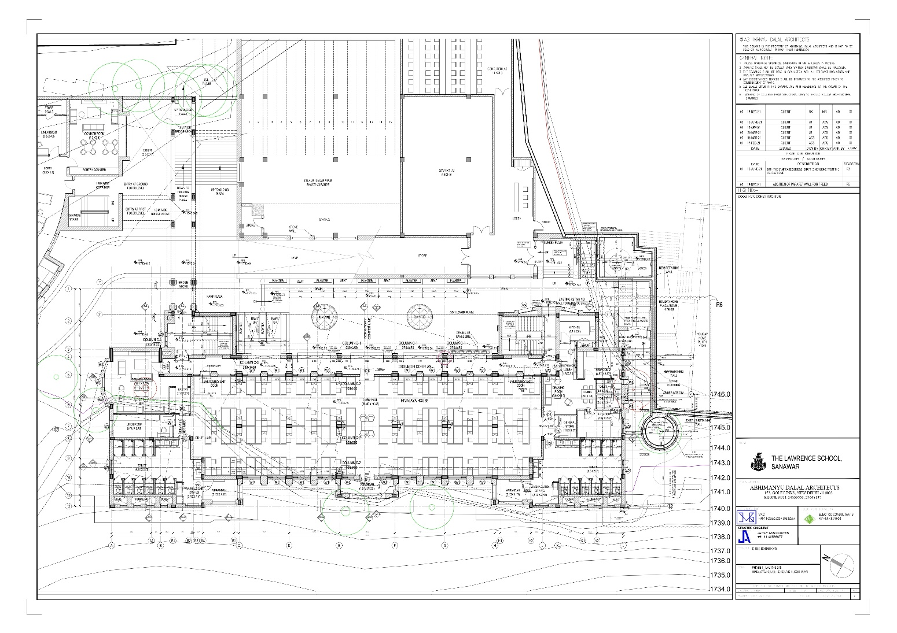

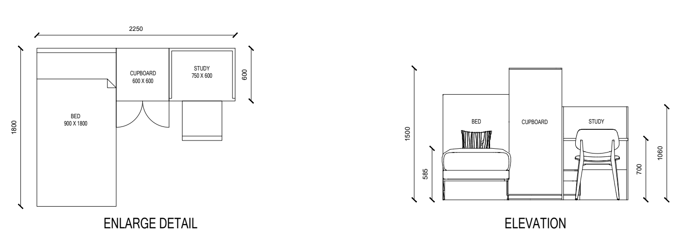

**DORMITORY:**

Frame – Solid Wood

Dividers & Platform – 19 mm Ply Board

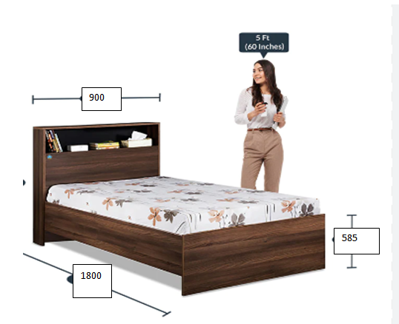

**STUDY TABLE:**

1. The table shall be of size 750 (W) X 600 (D) X 700 (H)

Preferred Design – As shown in picture with 2 no’s of shoe rack and shocks hanging bar. The table shall have 2 drawers running on telescopic channels.

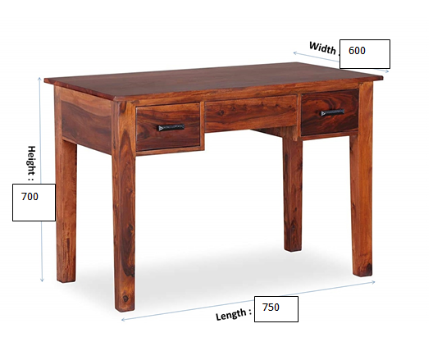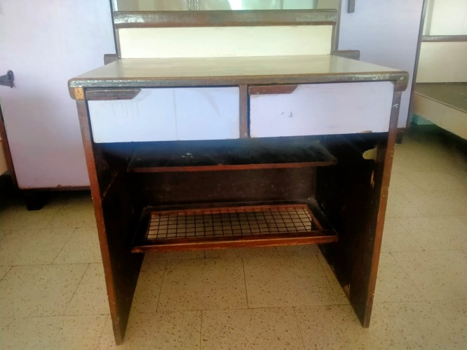

**ALMIRAH**

**A Sample of the required Almirah has been installed in the Dormitory. All vendors are requested to see the Approved Sample and Quote for the same product and specifications.**

1. Height (With shoe rack 150 mm in bottom): 1650 mm
2. Width of Individual Unit: 600 mm
3. Depth: 600mm

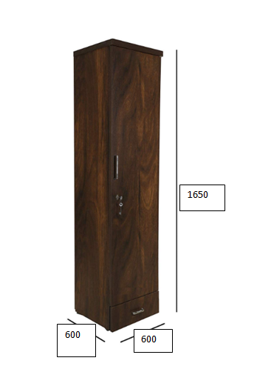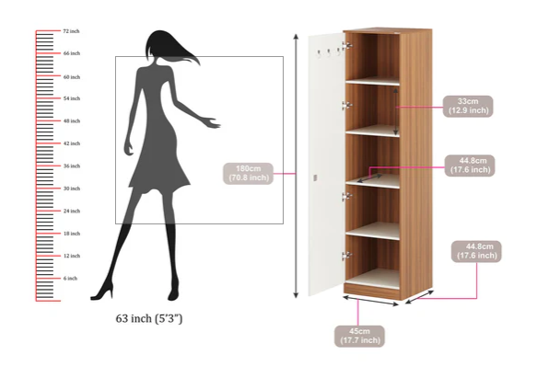

Study Chair

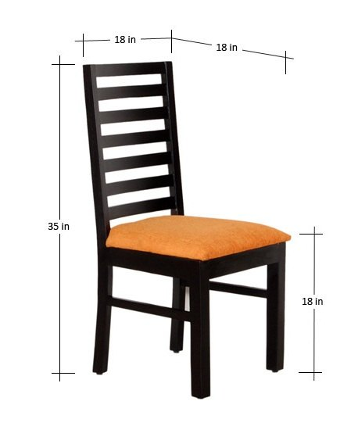

Dining Table

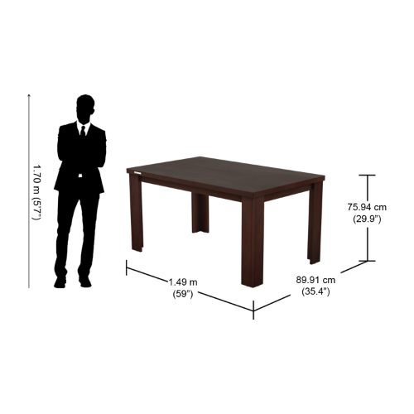

Coffee Table 4 seater

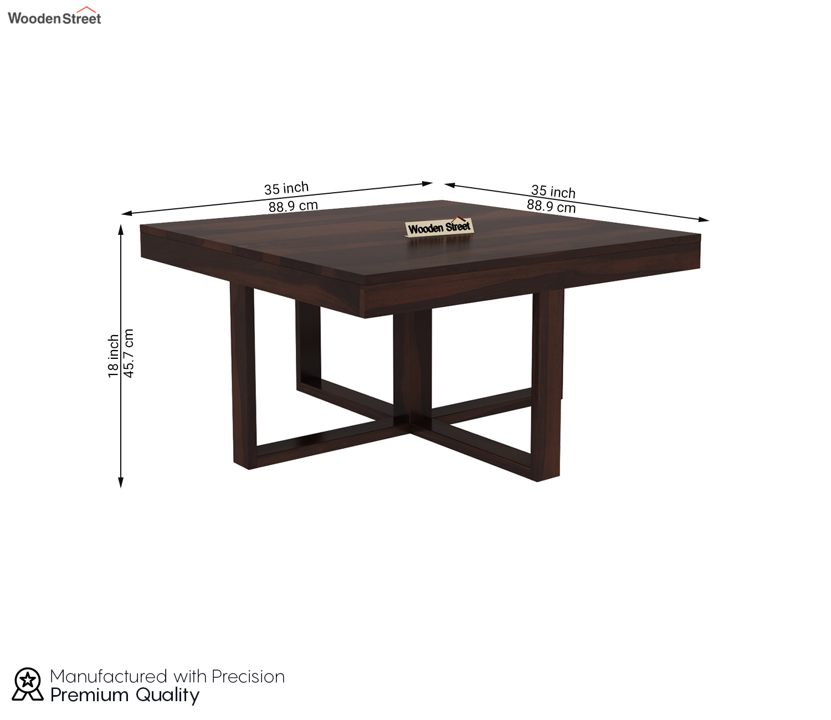

Sofa Set 3 Seater+Cushion

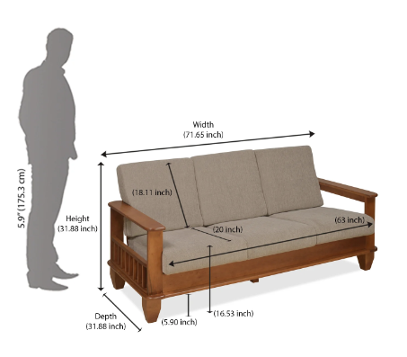

Sofa Set 2 Seater (1+1)+ Cushion

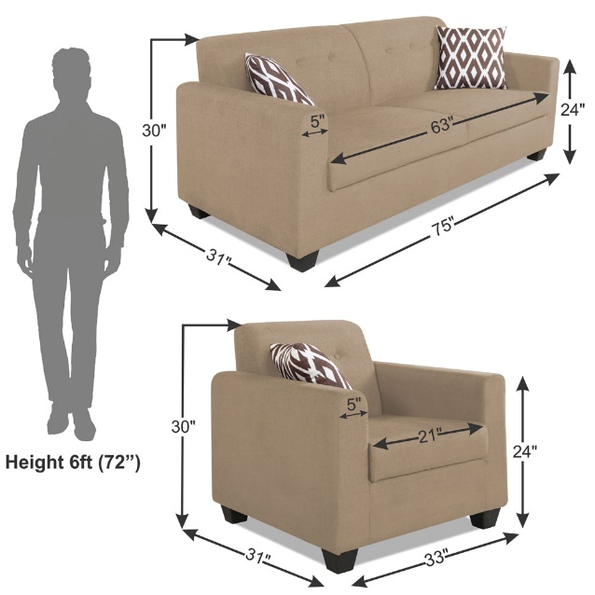

Peg Table

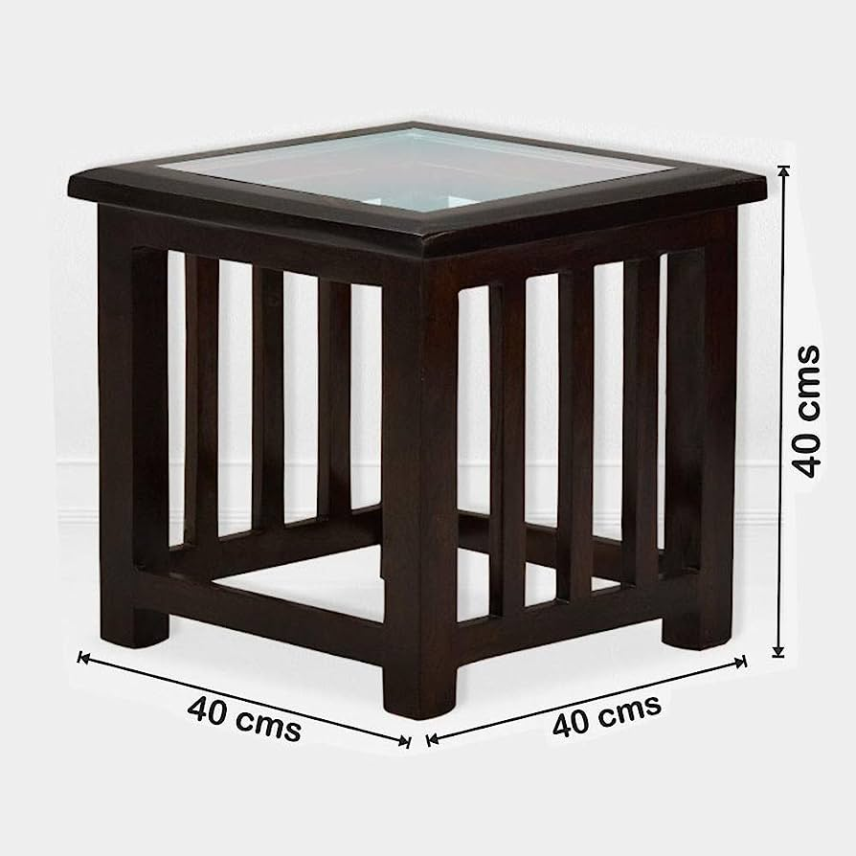

Bed Side Table

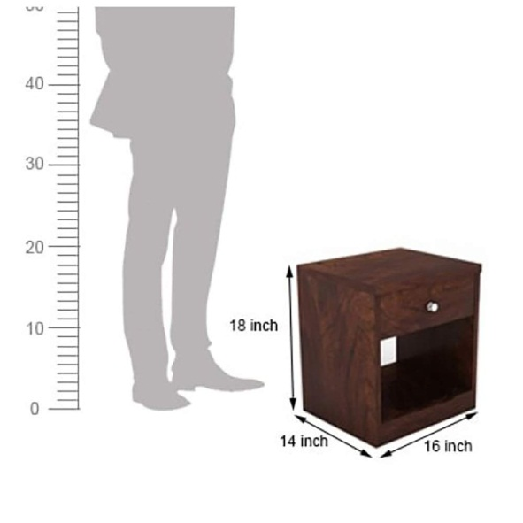

Round Table

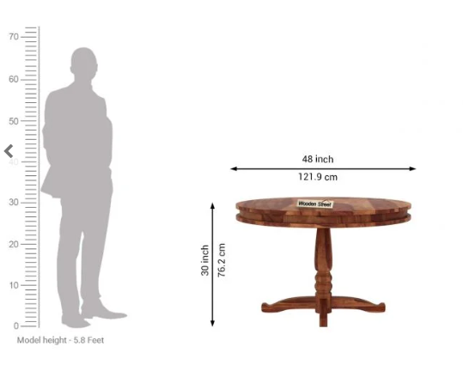

|  |  |  |  |  |  |
| --- | --- | --- | --- | --- | --- |
| **BILL OF QUANTITIES** | | | | | |
| **S.NO.** | **Description of ITEM** | **Unit** | **Quantity** | **Rate** | **Amount** |
| 1 | Providing, Supplying and Installation of Single Bed in Solid Wood as per drawings/specifications/attached picture include all necessary fitting and all complete up to the satisfaction of the engineer in charge.(Size – 900x1800x585 )  Frame – Solid Wood  Dividers & Platform – 19 mm Ply Board | Each | 120 |  |  |
| 2 | Providing, Supplying and Installation of Study Table in Solid Wood as per drawings/specifications/attached picture in Dormitory complete up to the satisfaction of the engineer in charge. (Size – 750x600x700 ) | Each | 112 |  |  |
| 3 | Providing, Supplying and Installation of Almirahs in Solid Wood as per drawings/specifications/attached picture in dormitory complete up to the satisfaction of the engineer in charge. (Size – 600x600x1650 ) | Each | 120 |  |  |
| 4 | Providing, Supplying and Installation of Hostel Room Study chair as drawings/specifications/picture attached in dormitory complete up to the satisfaction of the engineer in charge. | Each | 112 |  |  |
| 5 | Dining Table | Each | 2 |  |  |
| 6 | Coffee Table 4 seater | Each | 4 |  |  |
| 7 | Sofa Set 3 Seater+ Cushion | Each | 8 |  |  |
| 8 | Sofa Set 2 Seater (1+1)+ Cushion | Each | 4 |  |  |
| 9 | Peg Table | Each | 2 |  |  |
| 10 | Bed Side Table |  | 8 |  |  |
| 11 | Round Table |  | 2 |  |  |

**Area wise Details of Furniture**

|  |  |  |  |  |
| --- | --- | --- | --- | --- |
| Areas | Dormitory | Common Room | Matron Accommodation | Total |
| Single Bed 900x1800 x585 | 112 |  | 8 | 120 |
| Single Almirah 600x600x1650 | 112 |  |  | 112 |
| Chair | 112 |  | 8 | 120 |
| Study Table 750x600x700 | 112 |  |  | 112 |
| Dining Table |  |  | 2 | 2 |
| Coffee Table 4 seater |  | 2 | 2 | 4 |
| Sofa Set 3 Seater+ Cushion |  | 6 | 2 | 8 |
| Sofa Set 2 Seater(1+1)+ Cushion |  | 2 | 2 | 4 |
| Peg Table |  |  | 2 | 2 |
| Bed Side Table |  |  | 8 | 8 |
| Round Table |  | 2 |  | 2 |

**RATES SHALL BE INCLUSIVE OF THE FOLLOWING:**

1. All Taxes, Delivery, Installation, Testing, Commissioning.
2. Contractor will keep the premises clean at all times and do complete deep cleaning and sanitization of all furniture and staff room area before handing over the site.
3. All tools, plants, labour, materials, equipment, technical staff etc. Required to complete the work up to the satisfaction of the engineer in charge.
4. All equipment, mounts, suspenders, brackets, level adjusters and other consumables as may be required to complete the work satisfactorily.
5. Making shop drawings for the complete work, modifying them as may be required as per owners’ requirements and taking approval of shop drawings before proceeding with the work at site.
6. 2 years guarantee period with maintenance including all tools, plants, parts, labour, materials, supervision and technical support staff.