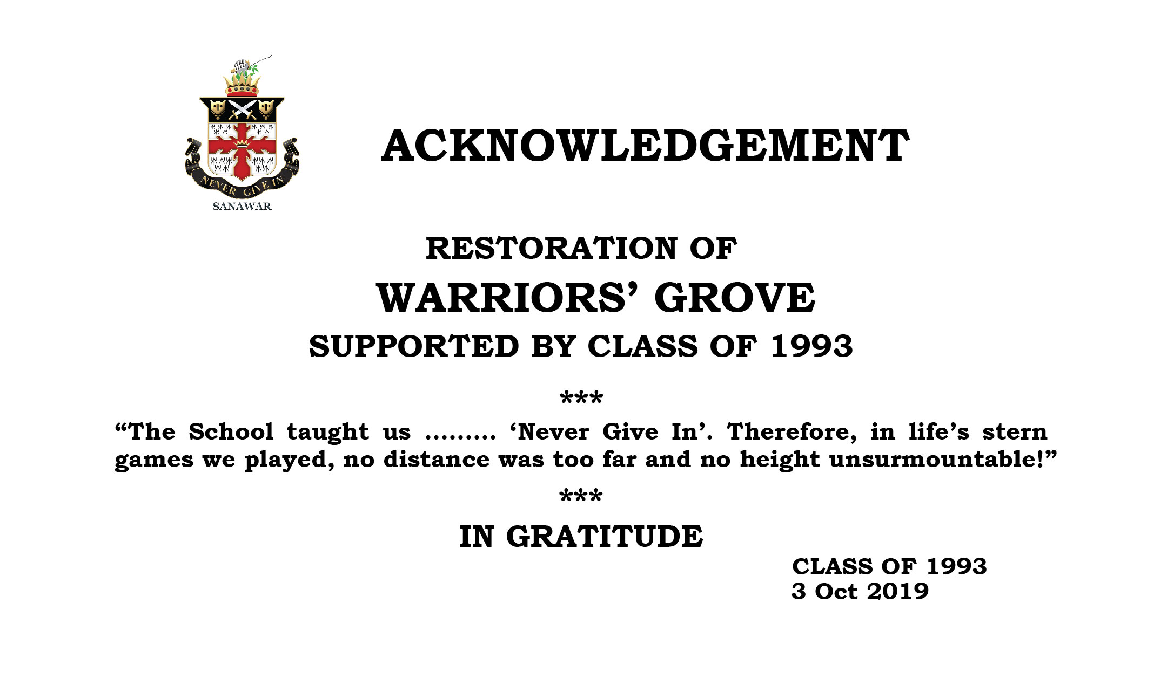

India’s premier co-educational residential public school, founded in 1847, invites tenders from reputed caterers having a valid food license to operate a cafeteria in the school Premises.

Open Area: -15 feet X 36 feet.

Student & Staff Strength: 1000

Proposals in a sealed envelope need to be submitted at the School Main Gate by 03:00 p.m. on 05/09/2023. For further details visit our website [www.sanawar.edu.in](http://www.sanawar.edu.in) or contact the School Office. (Phone No. 01792-261208, 209 & 229).Last **Date of Submission: By 3 pm on 05/09/2023**

**AGENCY TO RUN CAFETERIA AT THE LAWRENCE SCHOOL, SANAWAR**

**THE LAWRENCE SCHOOL, SANAWAR®**

**Distt. Solan, Himachal Pradesh (India) - 173202**